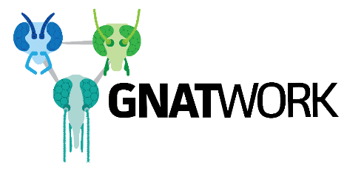 | The Gnatwork  Intended use of resource / data
Open access resources and data provided by The Gnatwork should be used for the intended purpose only, as specified below.
Title of resource
GN_31: Morphological identification key for the Culicoides fauna of Ghana

Authored by
Marion England
DOI
Description
Key of morphological features for identification of female specimens in ethanol. Species list includes those previously identified in Ghana and/or surrounding countries.

Intended use
Scientific research use and training purposes.

Restrictions on use
Content is not to be redistributed in the public domain (e.g. presentation, lecture, online or in publications).

Resource history
N/A

